The Jockey Club Vitality Run
Organised by the Sports Commission Co-ordinated by the Community Sports Committee
Co-organised by the 18 District Councils, the Leisure and Cultural Services Department,
the Sports Federation & Olympic Committee of Hong Kong, China and the Hong Kong Amateur Athletic Association
【Prospectus】
 | Purpose | ： | Scheduled for 23 April to 28 May 2017, the 6th Hong Kong Games (HKG) will cover eight sports, namely the athletics, badminton, basketball, futsal, swimming, table tennis, tennis and volleyball. A series of public participation activities will also be launched to enable wider participation. The Jockey Club Vitality Run is one of these activities and is suitable for people of different ages and abilities. All running fans and their families and friends are welcome to share the fun of running and show support for the HKG.
 | Date | ： | 8 January 2017 (Sunday)
 | Suggested Arrival Time | ： | 1 hour before the start times of the respective categories
 | Start Time | ： | 10 km Run – 8:30 a.m.  3 km Run – 9:00 a.m.
 | Start | ： | Yuen Wo Road (West Bound) near Sha Tin Sports Ground
 | Finish | ： | Sha Tin Sports Ground
Programme Number, Category, Quota and Age:
Programme Number | Category | Quota | Age of Participant
40444660 | 3 km Run | 4 000 | All are welcome
40444659 | 10 km Run | 1 100 | Aged 16 or above (as at the event day)

 | Route:
 | 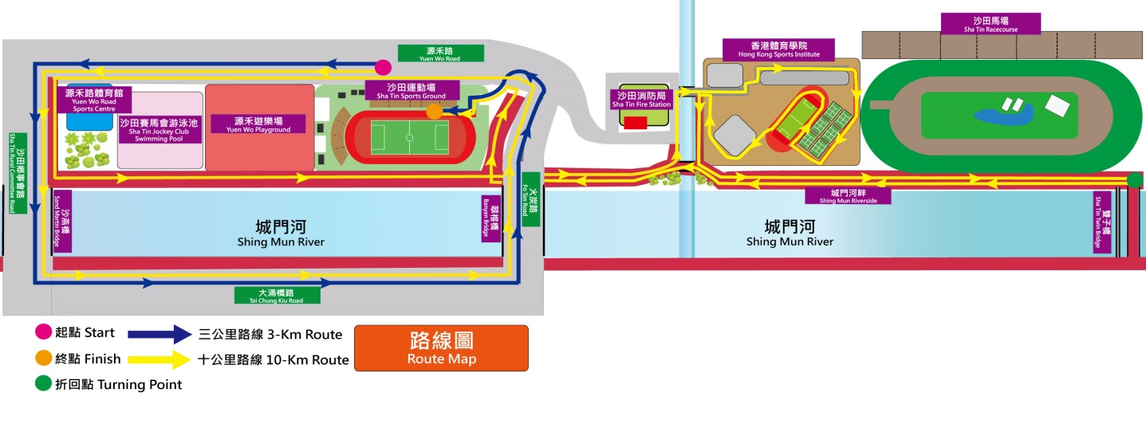
 | Enrolment Methods and Points to Note | ： | Enrolment starts at 8:30 a.m. on 16 November 2016 on a first-come-first-served basis through the following methods. Each person may enter a maximum of 4 participants each time (a maximum of 2 participants each time for online enrolment via the Leisure Link Internet Booking System).  - Enrolment in Person:  Applicants may bring along duly completed Enrolment Forms together with their valid identity documents (originals or copies) for enrolment at any District Leisure Services Office of the Leisure and Cultural Services Department (LCSD) or any leisure venue with Leisure Link Services.  - Online Enrolment via the Leisure Link Internet Booking System:  Applicants may log onto the Leisure Link website (http://leisurelink.lcsd.gov.hk) for enrolment.
 | Access to Prospectus and Enrolment Form | ： | The prospectus and Enrolment Form are available through the following channels:  - The dedicated website of the 6th HKG at www.hongkonggames.hk;  - District Leisure Services Offices of the LCSD;  - Leisure venues of the LCSD with Leisure Link Services; and  - Sports grounds of the LCSD in various districts.
 | Fee | ： | Free of charge
 | Souvenirs | ： | Each participant will receive a souvenir T-shirt and other souvenirs. Participants completing the run within the time limits (i.e. 45 minutes for 3 km Run and 90 minutes for 10 km Run) will also receive a certificate and a souvenir medal.
 | Other Prizes | ： | Participants interested to compete for the following prizes may enrol in the competitions when collecting their number bibs (i.e. from 2 to 6 January 2017):  Champion, 1st Runner-up and 2nd Runner-up of the Most Creative Costume Prize  Prizes will be awarded to the top 3 individual participants with the highest scores for their costume. The judging criteria include relevance to the theme of the HKG, creativity, colourfulness, helping to create a festive atmosphere, and the use of environment-friendly materials.  Champion, 1st Runner-up and 2nd Runner-up of the Overall Best Team Costume Prize  Prizes will be awarded to the top 3 teams with the highest scores for their team costume. Each team may consist of 2 or more persons, who can be members of a family or an organisation, or a group of friends. The judging criteria include relevance to the theme of the HKG, creativity, colourfulness, display of team spirit, and the use of environment-friendly materials.
 | Other Activities | ： | There will also be stage performances, game booths, a family area, a photo corner, etc. on the event day. Participants and their friends and families are welcome to join on the spot.
 | Collection of Number Bibs | ： | Participants shall bring along with their identity documents (originals or copies) when collecting their number bibs from the following locations from 2 to 6 January 2017:  - Main Plaza of Sha Tin Park, 2 Yuen Wo Road, Sha Tin, New Territories from 9:00 a.m. to 5:00 p.m. on 2 January 2017 (Monday); or  - Audio-Visual Room, 1/F, Leisure and Cultural Services Headquarters, 1-3 Pai Tau Street, Sha Tin, New Territories from 9:00 a.m. to 6:00 p.m. from 3 to 6 January 2017.  【Note: Participants are required to wear the number bibs on their chests before participating in the activity. They should ensure their number bibs are properly kept as no replacement bibs will be provided. No distribution/replacement of number bibs will be arranged on the event day.】
 | Clothing | ： | - Participants shall wear suitable sportswear and sports shoes, and bring their own sunscreen products, caps, raincoats, mosquito or insect repellent if necessary.  - Participants shall not wear clothing with commercial or promotional elements. The Organiser has the right to forbid anyone who contravenes the rules from taking part in this activity.
 | Points to Note | ： | - Participants should know whether they are physically fit to participate in the activity. If in doubt, they should consult a doctor before enrolment and participation. Participants should also have sufficient practice and warm-up exercises before the activity.
 |  |  | - On the event day, participants should pay attention to their personal conditions to see if they are physically fit for the activity. When feeling unwell during the activity, participants should seek help from nearby officials immediately.
 |  |  | - Participants may take out their own personal insurance if necessary.
 |  |  | - Supplementary information about this activity, including notes to participants and location map of the venue, will be provided through the dedicated website of the 6th HKG at www.hongkonggames.hk.
 | Inclement Weather Arrangements | ： | - If Tropical Cyclone Warning Signal No. 3 or above, or Red or Black Rainstorm Warning Signal is in force or issued at 6:00 a.m. on the event day, the activity will be cancelled.  - If the weather deteriorates during the activity, the Organiser may suspend the activity in view of the circumstances. Participants should pay attention to the announcements on the spot.
 | Enquiries | ： | 2601 7671

The Organiser reserves the right to amend this prospectus in the future.

The Jockey Club Vitality Run
Organised by the Sports Commission Co-ordinated by the Community Sports Committee
Co-organised by the 18 District Councils, the Leisure and Cultural Services Department,
the Sports Federation & Olympic Committee of Hong Kong, China and the Hong Kong Amateur Athletic Association
【Enrolment Form】
Notes on Personal Data:
- The information you have provided will only be used for the purposes of enrolment, compilation of statistics, future contact, opinion survey and promotion of activities organised by the Organiser. Only the staff authorised by the Organiser will be given access to the information for the aforesaid purposes.
- Please contact the staff of the Secretariat of the 6th Hong Kong Games Organising Committee at 2601 7671 if you wish to request correction of or access to the information provided in this form.
- The provision of your personal data in this form is obligatory. If you do not provide sufficient personal data, your application will not be accepted.

- Category to be Entered (Please put a “” in the appropriate box)
□ 3 km Run (Programme number: 4044 4660) □ 10 km Run (Programme number: 4044 4659)

- Personal Data of Participant(s) (Please use BLOCK LETTERS for English. Each person may enter a maximum of 4 participants each time.)
 | Name | Sex | Date of Birth  (dd/mm/yyyy) | Identity Document  No. | *Name and Telephone No. of Person for Emergency Contact | Signature of Participant/  Parent/Guardian  for the Declaration
1.
2.
3.
4.
* Please consider whether prior consent of the person for emergency contact should be obtained before entering his/her name and telephone number.

- Declaration
(Please sign in the “Signature of Participant/Parent/Guardian for the Declaration” column above to confirm the declaration below. For a participant aged under 18, his/her parent or guardian (aged 18 or above) must sign the declaration.)
- I/The participant above agree(s) to comply with all the rules of the above activity.
- I/The participant above am/is healthy and physically fit to participate in the above activity. The Organiser and co-organisers shall not be liable for any injury or death which I/the participant may suffer in the activity if the cause of injury or death is due to my/his/her own negligence or inadequacy in health or fitness.
- Personal Data of Contact Person
Name: Sex:
Residential Address:
Fax No.: Email Address:
Contact Telephone No.: (Mobile)

